M2 - W2 Assignment: Lambda Functions and Error Handling

In this assignment, you will work on your error handling skills as long as creating fast lambda functions on-the-go.

Exercise 1:

1. Write a function that takes as input as iterrable of numbers and calculates the square root of that number if the number is positive otherwise return a string returning something else (something meaningful, I am leaving that to your imagination).  This function should return an iterable of numbers. Do not forget to add the appropriate typings and dockstrings to your function.

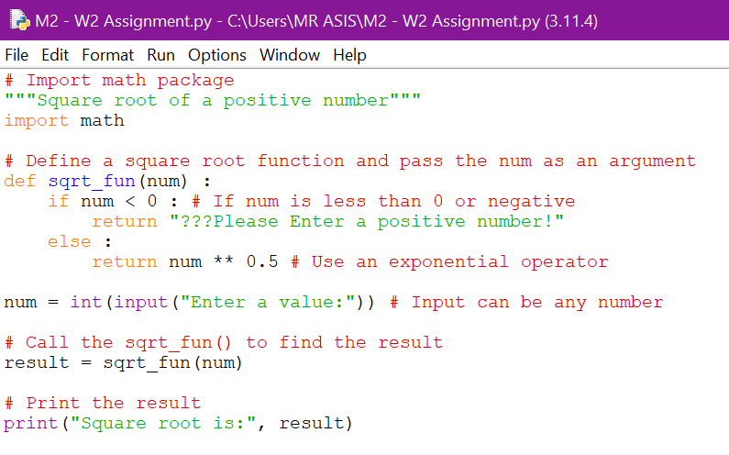

Output

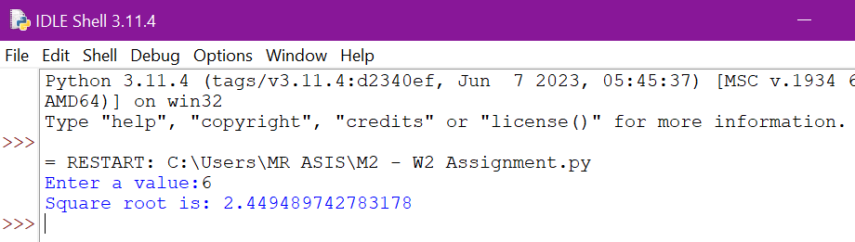

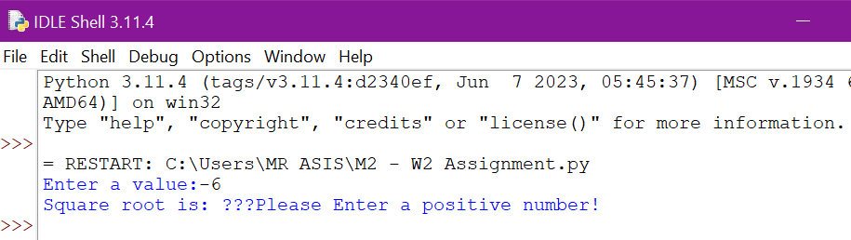

1. Rewrite the process calculated in Step 1 but using a lambda function instead. **This implementation should be faster than the one described in Step 1.**

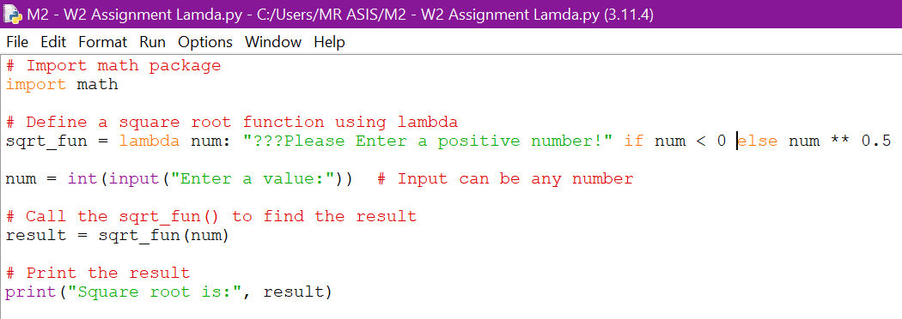

Output

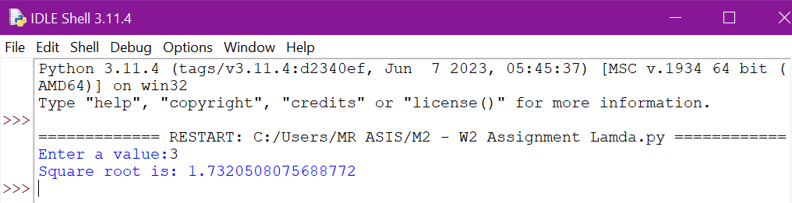

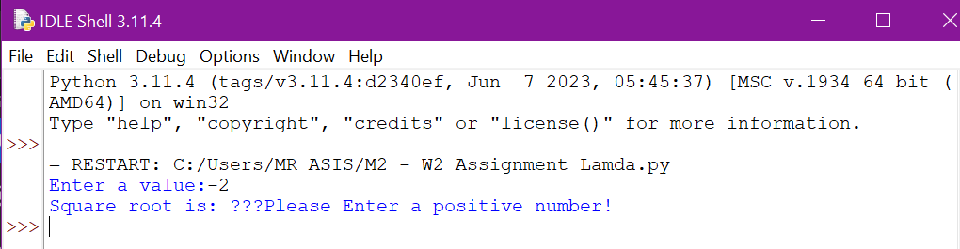

1. Calculate the time of execution for both implementations in Steps 1 and 2 . **Remember to return the same iterable for both Steps 1 and 2.**

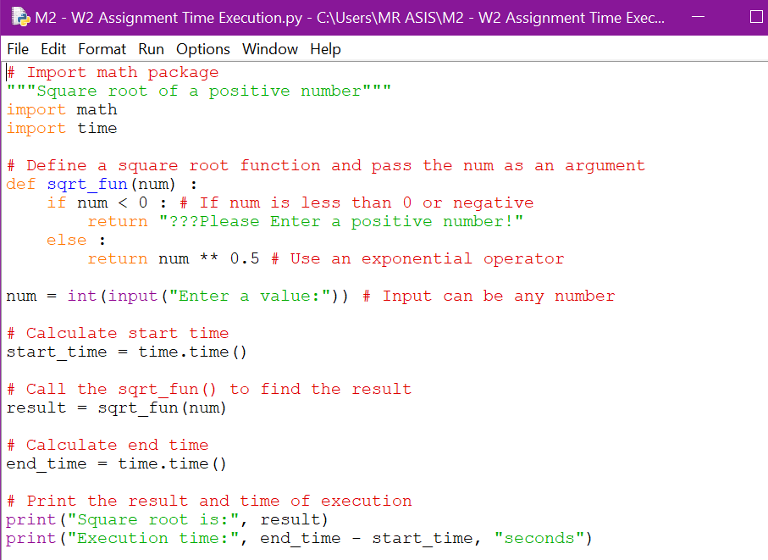

Output

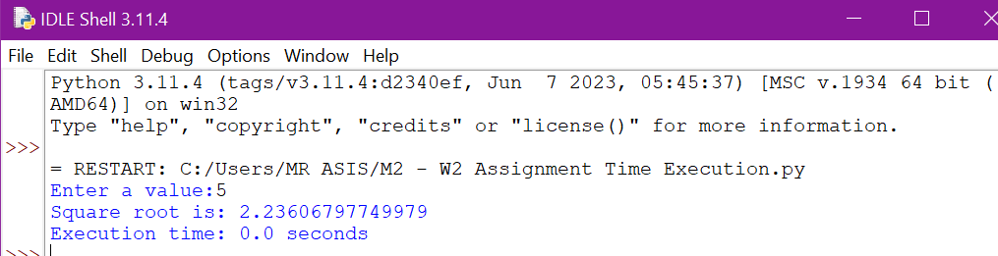

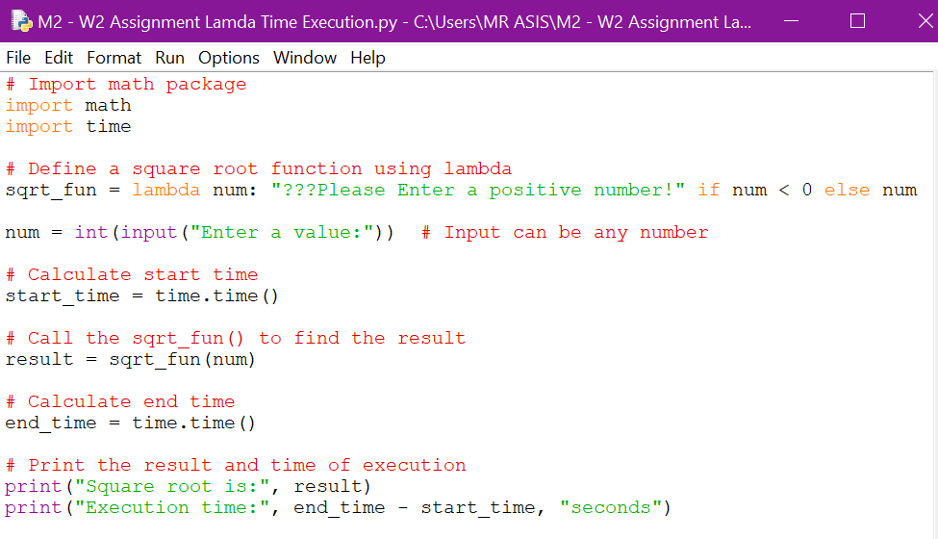

Output

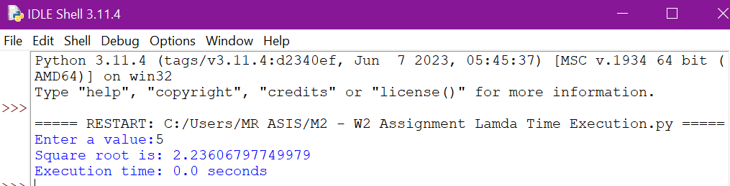

Exercise 2:

1. Save the output of Exercise 1, and then read the content of that file in your program*.* Apply either the function you wrote on the Step 1.1 or Step 1.2. What is the problem you are facing? (Give your answer in a comment block in your script).

|  |  |
| --- | --- |
| Codes | Output |
|  |  |
|  |  |
|  |  |

1. Modify the function in Step 1.1 so **that the function runs without issues.**Every time an operation fails, a meaningful message should be printed. (Do not check against individual types).

|  |  |
| --- | --- |
| Codes | Output |
|  |  |
|  |  |
|  |  |